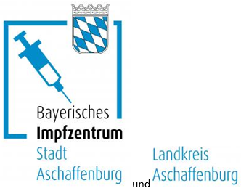

Vaccination center of the city and district of Aschaffenburg

The vaccination center for the city and district of Aschaffenburg is in the A3-Center in Hösbach, Industriestraße 2.
The vaccination center is open Monday to Friday from 8 a.m. to 8 p.m

Arriving by car:
Take the Hösbach exit on the A3.
There is enough parking space.

Arriving by bus:
Take the bus lines 42, 44 or 45 and stop at the „Industriestraße“ stop.

What about the bus timetable?
It´s on the internet: https://www.vab-info.de/Fahrplan
You can also call: VAB Customer Center Aschaffenburg, Telephone: 06021 1506666

All information about vaccination is available on the Internet:
www.aschaffenburg.de/impfen.

